**Unit 10: Sequences**

**Lesson 4: Arithmetic & Geometric Sequences, Discrete and Continuous functions**

**Objectives:**

* I can calculate the n-term in a sequence using an arithmetic or geometric sequence rule.
* I understand the difference between a continuous and discrete functions.
* I can identify an appropriate set of numbers for the discrete domain and range for a real life applications.

**Vocabulary**

In mathematics, a sequence is a collection of numbers (or other objects) that follow a particular pattern. The individual elements in a sequence are called terms.

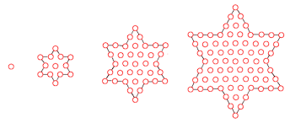

**Agenda:**

* Applications

**Focus Questions:**

* How can I identify the appropriate domain and range for a real life application?
* What is the connection between Arithmetic sequences and discrete linear functions?
* What is the connection between Geometric sequences and discrete exponential functions?

**Homework: Worksheet 10-3.**

**Online Support:**

* <https://www.youtube.com/watch?v=nO4sXLbwYTc>
* <https://www.youtube.com/watch?v=MSAWzIlPlkg>
* <https://www.youtube.com/watch?v=V02nV_qR_xQ>

Do Now:

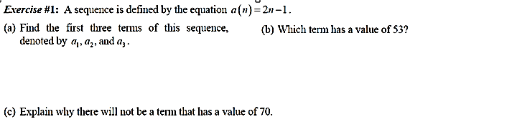

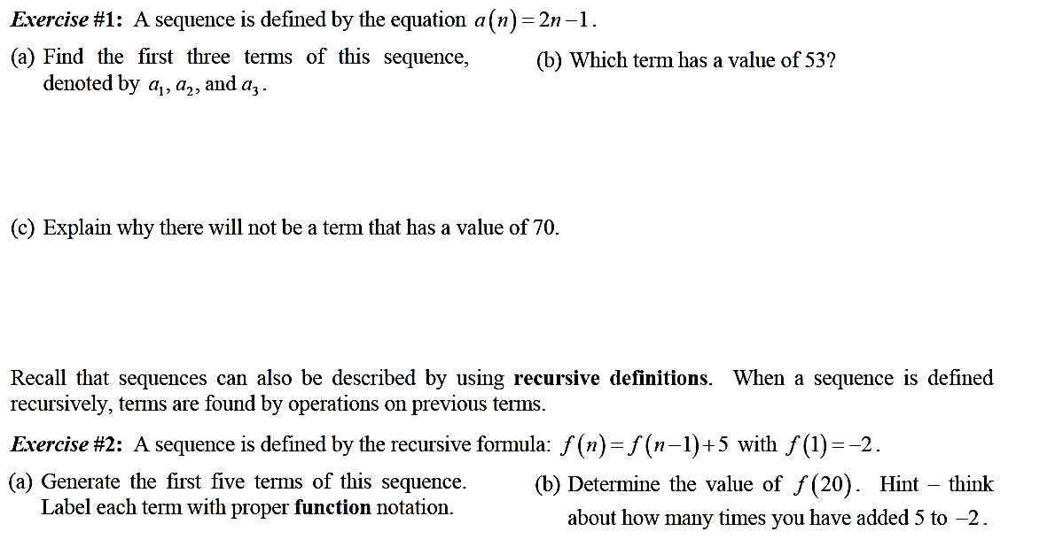

Blast from a very recent past:

|  |
| --- |
| Exponential functions. Write an exponential function from the given graph. Must provide a table of values and the coefficient correlation. |

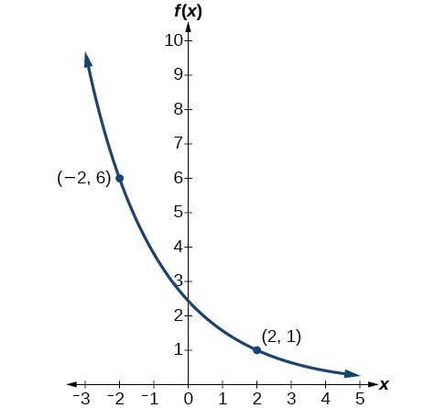

Lesson 10-4: Sequences in Real life

1. 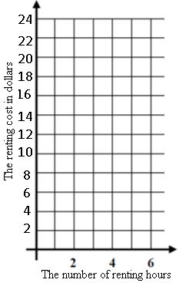A water park charges $8 for the first hour of renting a tube and $2 for each hour of use after that. This situation can be modeled by the following sequence

$a_{n}=8+2(n-1)$

1. Find the first 5 terms of the sequence
2. Is this sequence arithmetic, geometric or neither. Explain your reason.
3. Find $a_{20}$
4. Write a discrete linear function that represents the situation.

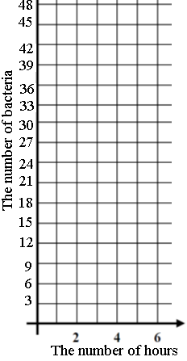

1. A bacteria population grows over time in hours in a manner that can be represented by the following sequence

$a_{n}=\left(3\right) 2^{n-1}$. Assume that the first term is the number of bacteria population after the first hour.

1. Find the first 5 terms of this sequence.
2. Is this sequence arithmetic, geometric or neither. Explain your reason

**CONTINUOUS VERSUS DISCRETE VARIABLES:**

**<https://www.youtube.com/watch?v=ikPkKfRi9dM>**

A **continuous variable** takes on all real number values between its extremes.

A **discrete variable** takes on isolated or unconnected values between its extremes.

Domains and ranges of discrete functions can be best represented specific set of real numbers; natural numbers, whole numbers, and integers. If we have a discrete domain that means we have a discrete function.

Example 1: Miranda has a lemonade stand where she is selling cups of lemonade for $0.50 per cup.

1. Identify the best set of real numbers that can represent the domain and range.
2. Do you think this is a discrete function? Why?
3. Fill out the table below for the amount of money, m, that Miranda makes for selling c number of cups.
4. Graph the function on the grid below
5. Write a function that represent the profit, m, made by selling c cups of lemonade.
6. List a sequence m(n) the represents the amount of money made selling n cups of lemonade. The first term is money made selling the first cup of lemonade.

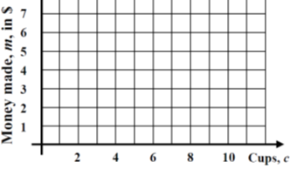

1. Write a general rule for the sequence.

[](https://www.google.com/imgres?imgurl=https://phpsljones.files.wordpress.com/2015/11/dog_ate_homework_x_ray_903255.jpg&imgrefurl=https://phpsljones.wordpress.com/2015/11/28/homework-is-live-3/&docid=M_p85grl4WmlkM&tbnid=LzV44xweH5ZVXM:&w=500&h=357&ei=TvTrVomNBYfse5y2iMAC)**Homework 10-4 Sequences: Name: _____________________**

1. Identify the appropriate set of real numbers that can best represent the domain in each of the following situations.

Officials in a town use a function, *C*, to analyze traffic patterns. *C*(*n*) represents the rate of traffic through an intersection where *n* is the number of observed vehicles in a specified time interval. What would be the most appropriate domain for the function?

1. {…−2, −1, 0, 1, 2, 3, …} 3. {−2, −1, 0, 1, 2, 3}
2. zero, 1 half, 1, 1 and 1 half, 2, 2 and 1 half 4. {0, 1, 2, 3, …}

2.Which domain would be the most appropriate set to use for a function that predicts the number of household online-devices in terms of the number of people in the household?

1. Integers 3. whole numbers
2. irrational numbers 4. rational numbers

3. The go-kart racing charges are $5 for go-kart license and $2 for each lap. This situation can be modeled by the following sequence $a_{n}=7+2(n-1)$

1. Find the first 5 terms of the sequence assuming the first term is the cost of one lap.

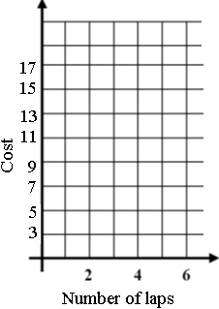

1. Is this sequence arithmetic, geometric or neither. Explain your reason
2. Find $a_{20}$
3. Write a discrete linear function that represents the situation.

4.A turtle population grows in a manner over time in hours that can be represented by the following sequence $a_{n}={5(5)}^{n-1}$. Assuming that the first term is the number of turtles after the first hour.

1. 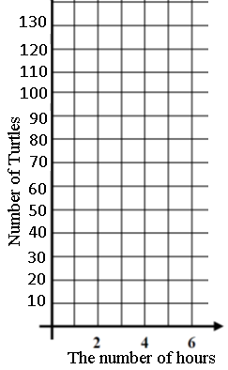List the first 5 terms of this sequence.
2. Is this sequence arithmetic, geometric or neither. Explain your reason.
3. Find $a_{8}$ and explain the meaning of it.
4. Write a discrete exponential function that represents the situation.

5.An online company lets you download songs for $0.99 each after you have paid a $5 membership fee. Which domain would be most appropriate to calculate the cost to download songs?

1. rational numbers greater than zero 3. whole numbers greater than or equal to one
2. integers less than or equal to zero 4. whole numbers less than or equal to one